

## Department of Psychology

1835 Neil Avenue

Columbus, OH 43210

September 16, 2019

Professor Ori Friedman

Associate Editor

*Cognition*

Dear Professor Friedman:

Thank you for considering our manuscript entitled *Attentional mechanisms drive systematic exploration in young children* (manuscript number: COGNIT-D-18-00574), and for inviting us to revise and resubmit it. The reviewers offered a number of thoughtful comments and suggestions. In light of those comments and suggestions, we have made substantial improvements to our manuscript. This includes collecting new data from a sample of 108 adults and comparing them to the children’s data included in the manuscript. In addition to these new data and analyses, improvements have been made to the Introduction and Discussion to achieve a broader and more nuanced treatment of the issues at stake, and to better situate the study’s conceptual motivation and theoretical implications. We believe that all of these changes help to highlight the significance and novelty of our findings, and that our study constitutes an important step in better understanding the critical processes underlying decision-making and their role in cognitive development, making it of interest to a wide audience of cognitive scientists and a good fit for publication in *Cognition*. We hope that you will find this version acceptable for publication, and we look forward to hearing from you.

Sincerely,



Vladimir Sloutsky

Professor of Psychology

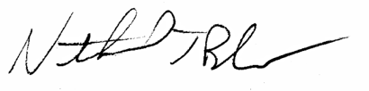

Nathaniel Blanco, Ph.D.